Laxmi Charitable Trust’s
Sheth L.U.J College of Arts & Sir M.V. College of Science and Commerce Department of Information Technology (B.Sc.I.T Semester IV) Data Analysis with SAS/SPSS/R
Module II
Practical – 7
Roll No.: S022 | Name: Neeraj Mishra
Class: SYIT | Batch: 1
Date of Assignment: 17-01-2026 | Date/Time of Submission: 17-01-2026

Aim :- Performing one-way ANOVA using aov() (R)
Code :- library(readxl)
one_way_anova <- read_excel("C:/Users/mvluc/Downloads/one_way_anova.xlsx")
View(one_way_anova)

library(readxl)

# Read Excel file
data1 <- read_excel("one_way_anova.xlsx")

# One-way ANOVA
anova_one <- aov(Marks ~ Teaching_Method, data = one_way_anova)
summary(anova_one)

Output :-

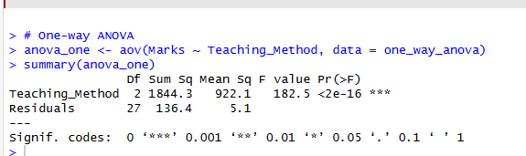

Laxmi Charitable Trust’s
Sheth L.U.J College of Arts & Sir M.V. College of Science and Commerce Department of Information Technology (B.Sc.I.T Semester IV) Data Analysis with SAS/SPSS/R
Module II
Practical – 8
Roll No.: S022 | Name: Neeraj mishra
Class: SYIT | Batch: 1
Date of Assignment: 17-01-2026 | Date/Time of Submission: 17-01-2026

Aim :- Performing two-way ANOVA using aov() (R).
Code :-
library(readxl)
two_way_anova <- read_excel("C:/Users/mvluc/Downloads/two_way_anova.xlsx")
View(two_way_anova)

library(readxl)

# Read Excel file
two_way_anova <- read_excel("two_way_anova.xlsx")

# Convert to factors
two_way_anova$Gender <- as.factor(two_way_anova$Gender)
two_way_anova$Study_Hours <- as.factor(two_way_anova$Study_Hours)

# Two-way ANOVA
anova_two <- aov(Score ~ Gender * Study_Hours, data = two_way_anova)
summary(anova_two)
Output :-
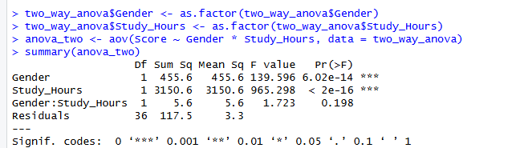

Laxmi Charitable Trust’s
Sheth L.U.J College of Arts & Sir M.V. College of Science and Commerce Department of Information Technology (B.Sc.I.T Semester IV) Data Analysis with SAS/SPSS/R
Practical 9
Roll No.: S022 | Name: Neeraj mishra
Class: SYIT | Batch: 1
Date of Assignment: 17-01-2026 | Date/Time of Submission: 17-01-2026

Aim :- Conducting Chi-square tests using chisq.test() (R)
Code :-
library(readxl)
chi_square <- read_excel("C:/Users/mvluc/Downloads/chi_square.xlsx")
View(chi_square)

library(readxl)

# Read Excel file
data3 <- read_excel("chi_square.xlsx")

# Create contingency table
table_data <- as.matrix(chi_square[,2:3])
rownames(table_data) <- chi_square$Gender
chisq.test(table_data)Output :-

output-:
